PRESS RELEASE
CHASING DONNAFUGATA
The bond between FAI and Donnafugata is renewed with the exhibition dedicated to “Illustrations by Stefano Vitale, wine and Sicily.” Through the works of the artist who has made the Sicilian winery's labels unique, a story of universal values is staged at Milan;
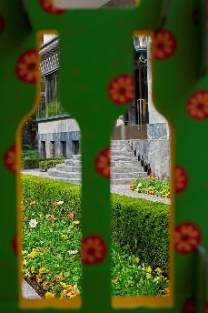
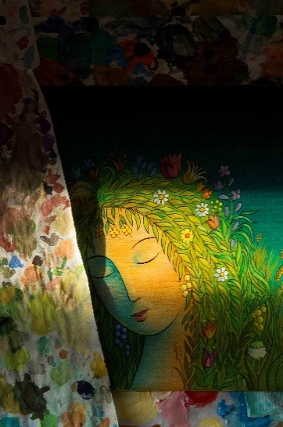
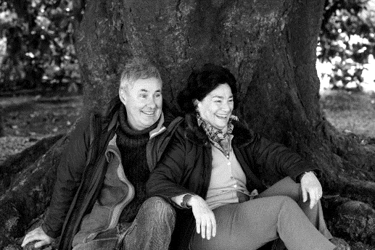
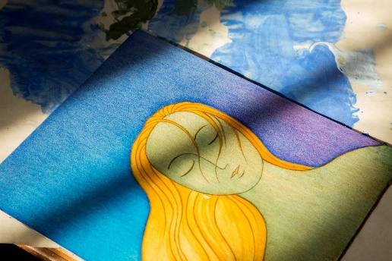
an exhibition project that also proposes a multisensory experience of music and tasting.

INSEGUENDO DONNAFUGATA (CHASING DONNAFUGATA) is the exhibition that presents the work of Stefano Vitale and the special relationship that binds the illustrator to the Rallo family of Donnafugata, on the one hand, and this winery to FAI – Fondo Ambiente Italiano (National Trust for Italy), on the other. In the splendid setting of Villa Necchi Campiglio, in the heart of Milan, the artist's original drawings and illustrations: the works that gave rise to the Donnafugata labels and that recount wine and Sicily through an extraordinarily identifying fantastic and feminine language, will be exhibited.
The exhibition project has the structure of a story that from the simple sign and pure color aims, however, to unveil universal themes such as courage, innovation and friendship. Thus, as in a modern-day Odyssey, the narration traverses time and space, while anecdotes reveal the protagonists of the story, and with them the sentiments and values that guide their actions.
We have Gabriella and Giacomo Rallo, the founders of Donnafugata, she who - choosing this name - evokes Il Gattopardo (The Leopard), and then has the courage to innovate Sicilian viticulture, as well as to ask an illustrator to carry the color of her land in the labels; he, Giacomo, with the talent for transforming dreams and visions into an enterprise project. And then Stefano Vitale who, inspired by his friendship with Giacomo and Gabriella, becomes the passionate interpreter of the iconic universe symbolic of this donna-in-fuga (woman-in-flight), and of her many faces.
Then José and Antonio, the 5th generation of this historic family, arrive: José who, through music, experiments new ways of communicating wine, and Antonio, winemaker, custodian of a craftsmanship that with the heroic viticulture of Pantelleria reaches peaks of excellence recognized all over the world; these are the people at the helm of the new projects of a story in perpetual motion and for this, always to be chased.
And there is FAI - Fondo Ambiente Italiano: “When the Rallo family donated the Donnafugata Garden on Pantelleria to us in 2008 – says Marco Magnifico, Executive Vice President of FAI – I was moved by the wonder of this nuraghe with just one century-old orange tree that is nourished by dew; since then, with them, it has been sharing values and deep friendship; we are happy – Magnifico concludes – to host at Villa Necchi the exhibition of Vitale's illustrations and the Donnafugata labels, as cheerful and sunny as Sicily and its wines.”
A testimony to the bond between the Foundation and Donnafugata, the latest illustration created by Vitale depicts the giardino pantesco donated to FAI and will be one of the most representative works on display, symbol of their common commitment to education in beauty and the harmony between man and nature.
The exhibition also proposes a real multisensory experience of music – that of the Donnafugata Music&Wine CDs that will echo through the Villa – and of wine, that the visitors can taste in the garden. The installation has been curated by the architect Lorenzo Damiani who has succeeded in the not very easy task of integrating the materials exhibited in the already rich context of Villa Necchi; the photographs taken by the talented Guido Taroni enrich the exhibition and the catalog, while Virginia Taroni, brilliant videomaker, has realized the interviews with the protagonists of the story.
CHASING DONNAFUGATA: Illustrations by Stefano Vitale, wine and Sicily.
Villa Necchi Campiglio, Via Mozart 14 - Milan - from May 16 to July 22, 2018
The exhibition is included in the tour of the Villa: from Wednesday to Sunday (hours 10 - 18); admission 12 euros.

