PRESS RELEASE
With Fragore on Etna: the Donnafugata icon wine.
The new cru produced in Randazzo, in contrada Montelaguardia,
is an icon wine to join Mille e una Notte from Contessa Entellina and Ben Ryé from Pantelleria.
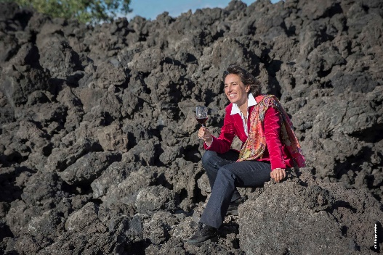
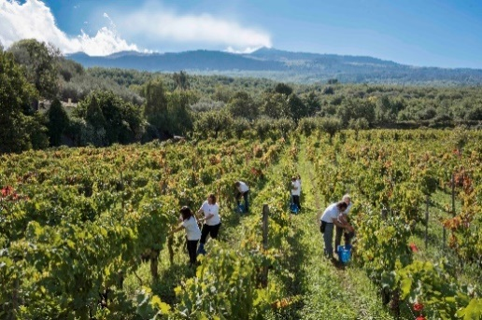
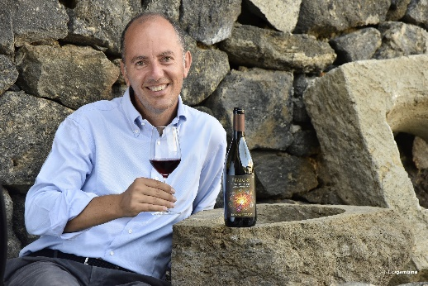
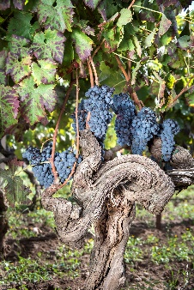

Fragore, the latest red born at Donnafugata produced from Nerello Mascalese from Contrada Montelaguardia in Randazzo, debuts at Vinitaly in Verona. The fruit of the 2016 harvest, for Donnafugata Fragore is a new icon wine of Etna where the company arrived to express its extraordinary potential, exactly how it happened in other prestigious winegrowing areas in Sicily: with Mille e Una Notte in Contessa Entellina and Ben Ryé on Pantelleria.
The vineyards in Montelaguardia, just over 4 hectares, are located at 750 meters above sea level. In this district the composition of the terrain is the fruit of the lava flows of the fifteenth and sixteenth century; the interaction between these terrains, their microclimate and the vineyards, even 70 years old and older, make the characteristics of the grapes produced here and of the resulting wine unrepeatable and exceptional. A terroir of particular charm with favorable pedo-climatic conditions: on one side “a Muntagna”, Etna, on the other the Nebrodi Mountains that partially act as a barrier against the currents of air heralding rain from the north; in Randazzo a sort of “climatic pocket” is created, characterized by lower rainfall than the other sides of the volcano.
The area where Fragore is born therefore enjoys the advantages of the altitude characterized by a wide variation between night and day temperatures, especially in summer, and the frequent Tramontana winds: these are the premises that favor the production of grapes of great aromatic finesse.
“In 2016 we harvested the Montelaguardia Nerello Mascalese in just a few days – says Antonio Rallo of Donnafugata –; the grapes we vinified in our Randazzo winery were beautiful, rich in mature polyphenols that have given us high quality structure”. And, in fact, Fragore is a wine that has an ample and deep bouquet, of elegance and volcanic personality; the fruity notes are very clear, also the flowery, spicy and balsamic notes, on the palate, integrated and supported by important tannins and remarkable persistence. “In few other regions of the world – Antonio Rallo concludes – you can achieve such complexity, able to evolve over time.”
The expression of Fragore recalls Donnafugata's imagery and the force of nature that creates and transforms. “We have always been projected towards the future – says José Rallo of Donnafugata – ever since our parents Giacomo and Gabriella founded the family winery. And the label of Fragore – that we also wanted to communicate through a splendid video animation – is a metaphor of our commitment that led us from western Sicily to the east, to Vittoria and on Etna; the illustrator, Stefano Vitale, captures this perpetual motion like that of an object in space, attracted by invisible gravities, and returns it with the appearance of a flaming woman, whose roar announces the energy of the volcano. A unique label, like the soul of this wine.”
Just over 15,000 bottles of Fragore 2016 have been produced, available for restaurants and wine shops; on the shelves, only a few months ago, at 54-56 euros a bottle. You can buy Fragore in Milan at Enoclub, Enoteca Grossi, Vini e Sapori, Incontri Divini; in Genoa at Vinoteca Sola; in Trento at Enoteca Grado 12; in Udine at Enoteca ACER; in Verona at Alcova del Frate; in Rome at Enoteca Achilli, Castroni and at Enoteca Bomprezzi; in Naples at Horeca Company; in Catania at Enoteca Doc Caffè del Duomo, Centro Vino e Liquori, La Dispensa del Gattopardo, Enoteca Bonaccorso, Antiche Delizie; in Palermo at Enoteca Vino Veritas, il Contalitro.
Marsala, 5 April 2019
Public Relations: Baldo M. Palermo baldo.palermo@donnafugata.it tel. +39 0923 724226
Laura Ellwanger pr.international@donnafugata.it tel.+39 0923 724226

Press Office: Nando Calaciura calaciura@granviasc.it cell. 3+39 38 3229837

