The Giardino Pantesco and the bond between Donnafugata and FAI.

The bond between FAI and Donnafugata is renewed with the exhibition CHASING DONNAFUGATA dedicated to “Illustrations by Stefano Vitale, wine and Sicily.”
Through the works of the artist who has made the Sicilian winery's labels unique,
a story of universal values is staged at Milan.

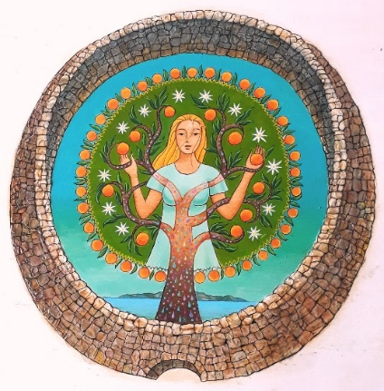
Donnafugata's bond with FAI - Fondo Ambiente Italiano (National Trust for Italy) owes much to Marco Magnifico, to professor Giuseppe Barbera and to their relationship of esteem and friendship with Giacomo Rallo, the founder of the Sicilian winery, who seized with enthusiasm the wish that a giardino pantesco (a garden on Pantelleria island) was donated to FAI.
Donnafugata then decided to arrange for the restoration of a garden, set among its vineyards on Pantelleria, in order to promote the knowledge of this ancient agricultural architecture self-sufficient as regards water, that reminds us how much water is a scarce, vital and precious resource.
The bond between Donnafugata and FAI, of which the winery is Corporate Golden Donor, is based on sharing a common commitment in the name of the values of sustainability and the safeguarding of the landscape well testified by the donation of the giardino pantesco, that took place in 2008.
These gardens are dry built lava stone towers, similar to nuraghi; generally, with a circular plan, they conserve, closed by a door, even just one citrus tree that, to the farmer, represented a precious vitamin factory. The Donnafugata Garden is 4 meters high, it has a diameter of 11 meters and encloses a century-old orange tree of the ancient Portugal variety.
The Pantellerian gardens offer an exemplary testimony to the extraordinary measures implemented to face adverse natural factors: the wall protects the plant from the wind and creates shade that reduces the evaporation of moisture from the soil and the transpiration of the plant. The dew condensation during nighttime, that contributes to meeting the water needs of the tree, is also very important.
And it is precisely on the scarcity of water and on the threats of climate change, that the giardino pantesco invites us to reflect. On Pantelleria – an island of farmers more than of fishermen – the gardens are also the testimonies to that same wisdom that animates the viticulture still active today on around 400 hectares of the island and that represents its main source of livelihood: a tradition that has UNESCO world heritage recognition for the alberello (low bushy) trained Zibibbo vine, whose finest fruit is the Passito di Pantelleria.

CHASING DONNAFUGATA: Illustrations by Stefano Vitale, wine and Sicily.
Villa Necchi Campiglio, Via Mozart 14 - Milan - from May 16 to July 22, 2018
The exhibition is included in the tour of the Villa: from Wednesday to Sunday (hours 10 - 18); admission 12 euros.

