Stefano Vitale, biographical notes.

The artist who has made the Sicilian winery's labels unique,
a story of universal values is staged at Villa Necchi in Milan, with
the exhibition INSEGUENDO DONNAFUGATA (CHASING DONNAFUGATA).

Stefano Vitale was born in Padova in 1958. When he was young he moved to Los Angeles to begin his studies in Economic and Social Sciences. After graduating he gave free rein to his most intimate inclination and enrolled at the Art College of Design in Pasadena.
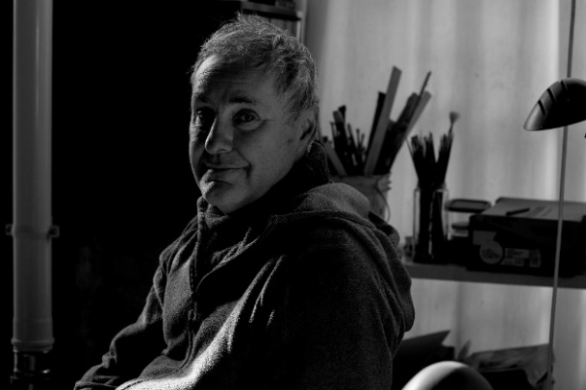
During his years in California, Vitale traveled extensively throughout Mexico and Central America remaining strongly influenced by the folk art of these places. “I have always trusted folk art more than official art – Vitale explains –. It is absolute sincerity, something that goes directly from the soul to the paper, the stone, the wood; folk art is like the art of a child.”
He moved to New York, and his career as illustrator really got going, in various fields from publishing to advertising, to packaging; after 15 years, Stefano Vitale returned to Italy, and settled in Venice; in the lagoon he “fished” floating pieces of wood and gave them new life, using them as boards on which to paint.
In the meantime, it was 1994, Vitale encountered Gabriella Anca Rallo, who together with her husband Giacomo had founded the Donnafugata winery: between them a professional collaboration was born that soon became a bond of deep friendship.
“Gabriella was a guest of one of my neighbors – Vitale recounts – she entered my studio to browse and saw my illustrations; we had just met and she suddenly said to me <Would you create a label for me? Why not try.> Gabriella had courage – Vitale continues – not me. She asked me to carry the colors of Sicily in the communication of the wine; they are strong, bright colors, making them was easy: the colors of Sicily are my colors.”
Over more than 20 years, Stefano Vitale has created the illustrations for 20 labels of Donnafugata wines, one for oil and others dedicated to the Donnafugata Music & Wine project and CDs. The latest work created by Vitale for Donnafugata represents the Giardino Pantesco (Pantelleria Garden) donated to FAI, symbol of the collaboration between the Sicilian winery and the Foundation, that has led to the exhibition “CHASING DONNAFUGATA”.

CHASING DONNAFUGATA: Illustrations by Stefano Vitale, wine and Sicily.
Villa Necchi Campiglio, Via Mozart 14 - Milan - from May 16 to July 22, 2018
The exhibition is included in the tour of the Villa: from Wednesday to Sunday (hours 10 - 18); admission 12 euros.

