Ben Ryé among the world's great sweet wines
The Passito di Pantelleria is among the wines selected for the ninth edition of the prestigious tasting “Les Vins Liquoreux du monde” held in France, in the heart of Sauternes.

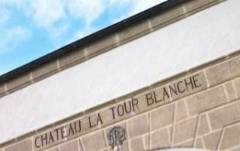
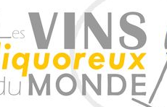

“Les Vins Liquoreux du monde”, the extraordinary tasting reserved for the finest sweet wines produced at an international level, including Ben Ryé, son of Zibibbo, the sun and wind of Pantelleria, will be held in Bommes, France on June 17.
The event, now in its ninth edition, as is tradition, will be held on the eve of Vinexpo Bordeaux, clou biennial appointment for the wine world. The theater of the event reserved for producers, sommeliers, journalists and trade will be the cellars of La Tour Blanche, a historic producer of the prestigious Sauternes denomination, where – as wished for by the founder – a school of viticulture and oenology was also established, among the most specialized in sweet and fortified wines still today.
Fine Tokays of Hungary, German Mosel wines, Austrian wines of Burgenland, Spanish wines of Malaga and other wines of excellence produced in Croatia and Greece will be tasted alongside the most important French sweet wines. The rare Canadian Icewine and South African Constantia will also be coming from overseas.
Italy will instead be represented by the Passito that Donnafugata has been producing on Pantelleria since 1989, in a context of heroic viticulture whose agricultural practice of the alberello vine has been inscribed on the UNESCO Representative List of the Intangible Cultural Heritage of Humanity; two vintages of Ben Ryé to be tasted, that of 2015 just released, and 2005, excellent testimonial of the longevity of this wine.

