PRESS RELEASE

Winergy, architecture and design for Pantelleria

On display at Donnafugata the projects for a Wine Museum and UNESCO Information Center, realized by students of the Catholic University of America.
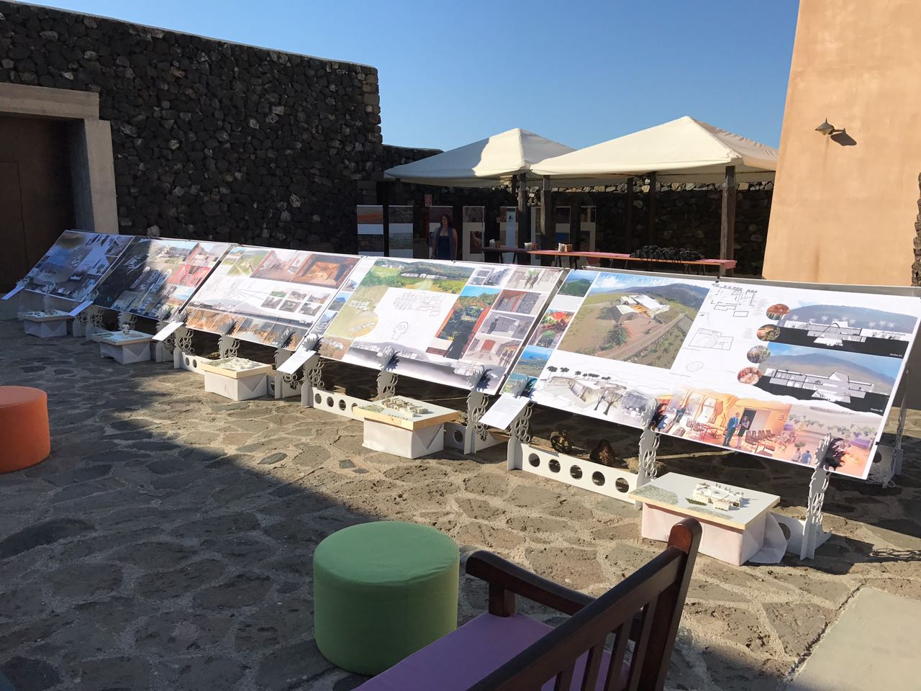
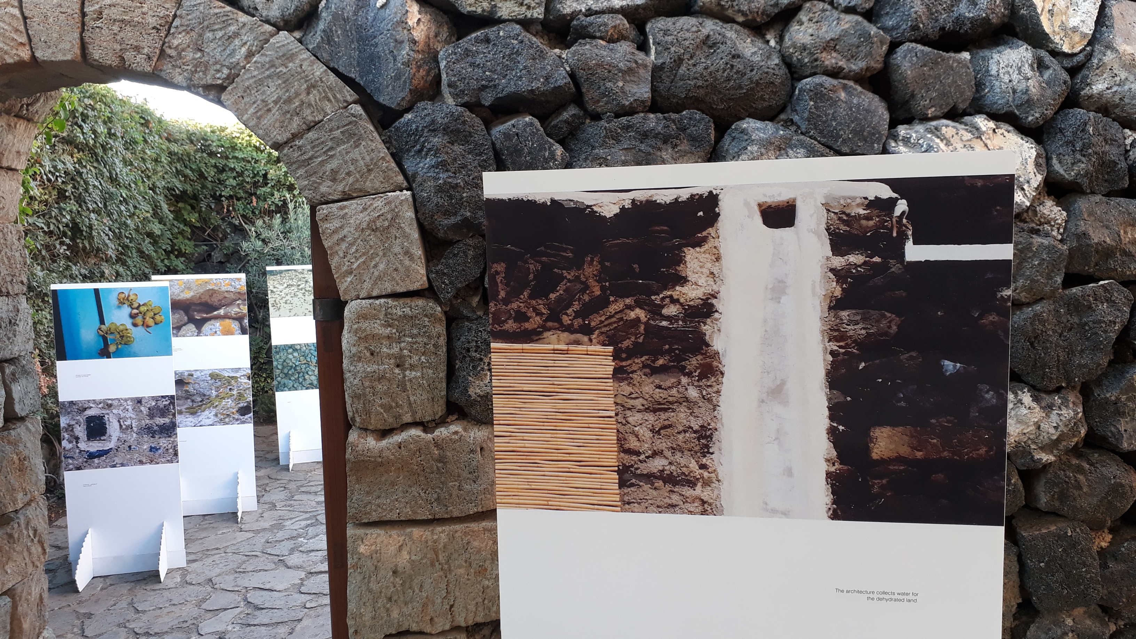
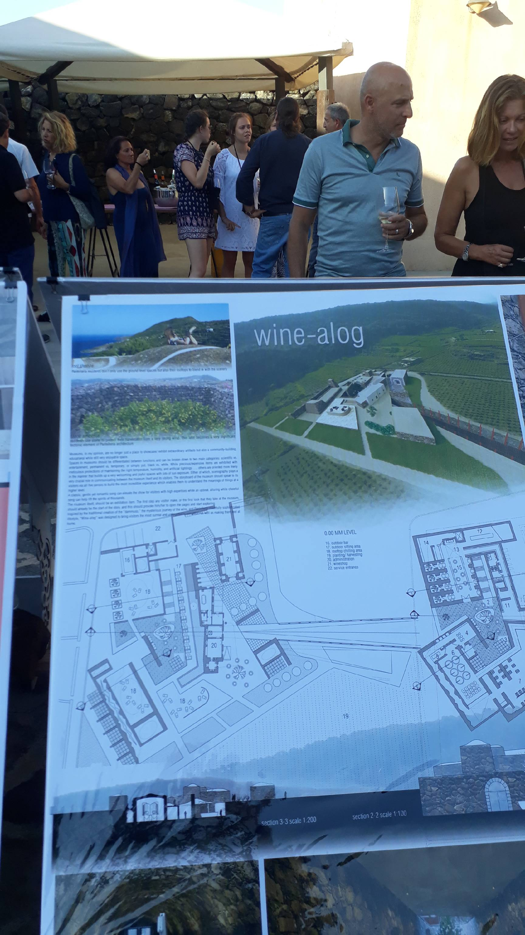
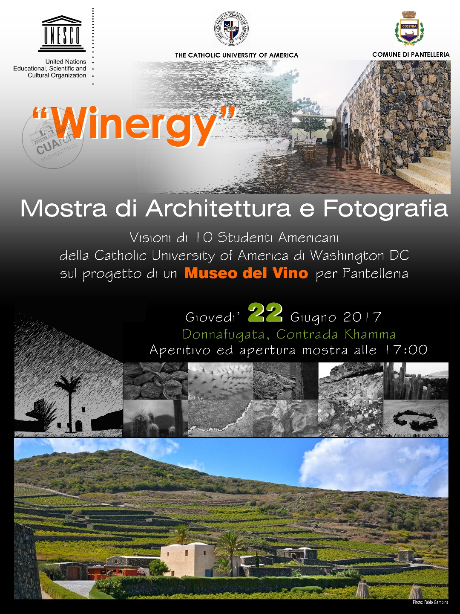
On June 22, Winergy, an exhibition realized by students of the Catholic University of America (CUA) Faculty of Architecture, was held at the Donnafugata winery on Pantelleria. The title Winergy – the union of “Wine” and “energy” – evokes the vitality that characterizes the wine and its production process on a volcanic island like that of Pantelleria.
Guided by their Professor Lavinia Fici Pasquina the students of CUA, Washington, presented their architectural visions for a possible Wine Museum to be built on Pantelleria at a real site, particularly linked to the development of the viticulture of the island: the Paulsen Institute of the Regional Department of Agriculture, located in Piana di Ghirlanda.
The students had already visited Pantelleria last year in order to immerse themselves in the nature and architecture of the island; an experience that deeply inspired the next design phase.
Thanks to the Commission for Cultural and Environmental Heritage of Trapani and to Roberto Monticciolo who suggested to base the project on the actual site of the Paulsen Institute, the students have had the opportunity to experience the site and the landscape in person.
At Donnafugata the students displayed as many as 10 illustrative plates, the fruit of several months of work, presenting their idea for the Museum. The projects include and maintain almost intact the existing structures of the Paulsen, and we witness a very interesting variety of stylistic approaches: from the most radical, to more traditional conceptions integrated with the surrounding landscape.
In the near future – as Mayor Salvatore Gabriele said – the Pantelleria Municipal Administration is planning to establish, in collaboration with CUA, a jury that will be called upon to choose the best project, to finance its implementation. A competition of ideas that has the objective of really creating a Museum, to promote the knowledge of the heroic viticulture and production processes that give rise to the precious wine, symbol of the island, Passito di Pantelleria.
The American students have also designed a project for a UNESCO Information Center, to be built at the port of Pantelleria. It would be a structure conceived for giving information to the numerous tourists visiting the island and to enhance the value of the extraordinary recognition of the agricultural practice of the alberello pantesco vine, UNESCO World Heritage.
Winergy also put on display photos by two other CUA students who had visited Pantelleria last October, exploring the vaster landscapes and the most suggestive details related to the nature and life on the island.
Marsala, 26 June 2017
Public Relations: Baldo M. Palermo baldo.palermo@donnafugata.it ph. +39 0923 7242267
Laura Ellwanger pr.international@donnafugata.it ph. +39 0923 724258Public Relations

Students, authors of the projects for a Wine Museum and UNESCO Information Center: Dylan Gallagher, Gabriella D’angelo, Tatianna Freeman, Rolled Almanza, Aisha Al-Bader, Nareg Khachadorian, Planel Nyontyen, Ian Walker, Dung Hoang, Amanda Ocello. Photo exhibition curated by: Ariadne Cerritelli and Sara Gordon. Professors, Staff and collaborators: Lavinia Fici Pasquina: Director and Professor; Davide Prete, John Nahra, Hussam Elkhrraz: Professors and support Staff; Valeria Persi, Ariadne Cerritelli: collaborators.

