PRESS RELEASE
Ben Ryé the most awarded sweet wine
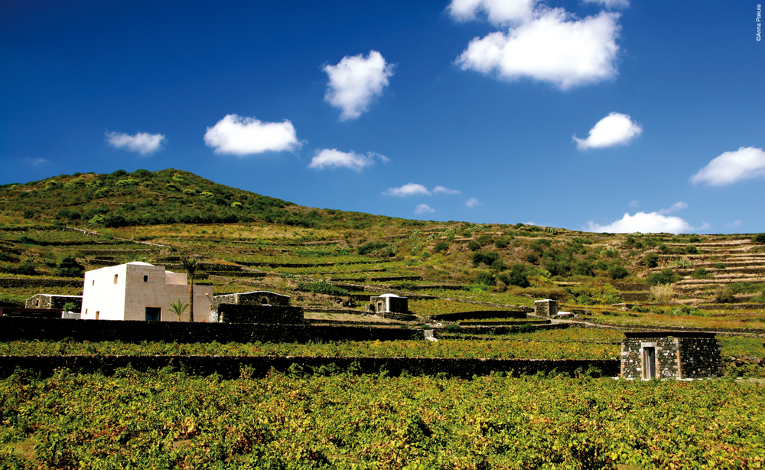
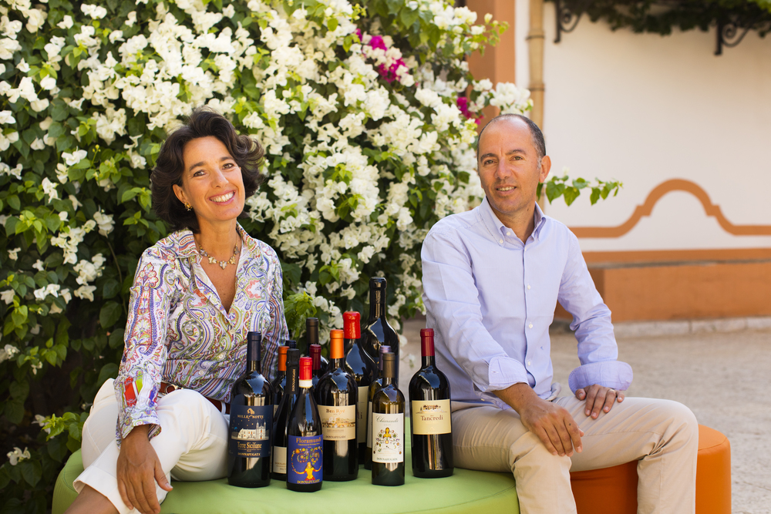
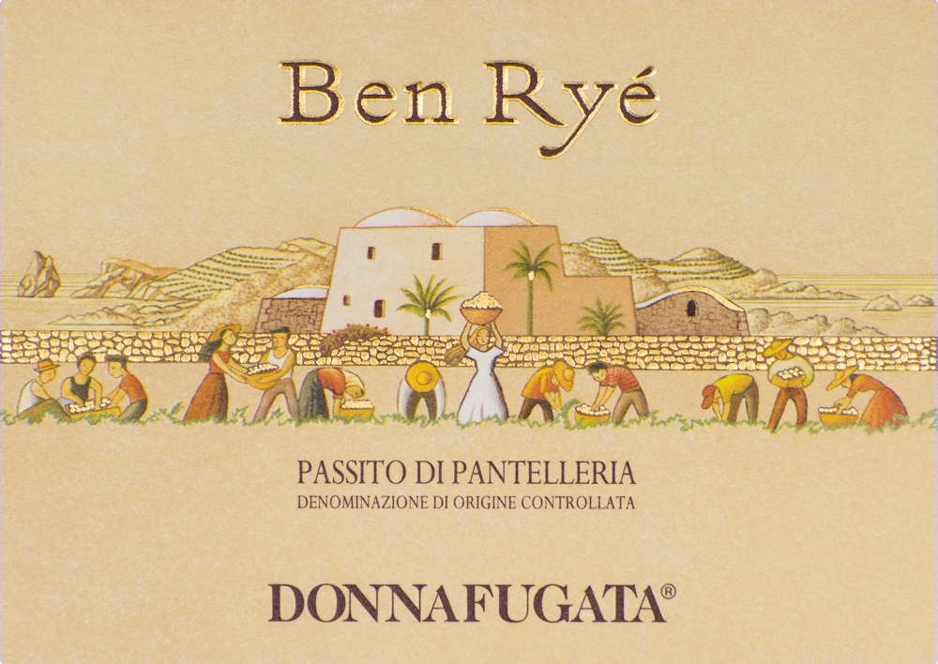
The Donnafugata passito achieves excellence according to the main guides to Italian wine and stands out in its category also according to international critics.

Also this year Ben Ryé Passito di Pantelleria, Donnafugata's icon, wins awards and takes its place at the top of the Italian sweet wines: this is the opinion of the 2018 editions of the main guides that review wines from the Belpaese.
In fact, the “Son of the Wind” has received 8 awards of excellence, getting the critics, whose judgments are traditionally presented at this time of year, to agree.
Ben Ryé vintage 2015 has been awarded Three Glasses by Vini d’Italia Gambero Rosso, the Super Three Blue Stars by I Vini di Veronelli, Five Clusters by Bibenda, Four Vines by Vitae Associazione Italiana Sommelier, the Crown by Vini Buoni d’Italia Touring Club.
In addition, Ben Ryé is in the Top 100 of L’Espresso among the “Wines to buy”, Vino Slow according to Slow Wine Slow Food and Best Italian Sweet Wine according to Luca Maroni who has given it a sonorous 99/100.
Exceptional testimonial of the heroic viticulture of Pantelleria – with its alberello cultivation UNESCO heritage, century-old vineyards, terraces and dry stone walls – for years Ben Ryé has been among the most appreciated sweet wines also according to international critics.
This year Decanter World Wine Awards has awarded Platinum to Ben Ryé 2014, a 95/100 vintage according to Robert Parker's Wine Advocate that has also dedicated a memorable vertical to this wine, of all the vintages produced, celebrating its role as one of the most appreciated sweet wines in the world.

Marsala, 13 November 2017

PRESS OFFICE Nando Calaciura calaciura@granviasc.it cell. 338 3229837
PUBLIC RELATIONS Baldo M. Palermo baldo.palermo@donnafugata.it tel. 0923 724226

