PRESS RELEASE
Art and Wine at Donnafugata
Floramundi on stage presents Carla Fracci.
Saturday 2 December at the historic cellars in Marsala, the great artist retraces her career and is the patroness of Floramundi, the new Donnafugata wine.
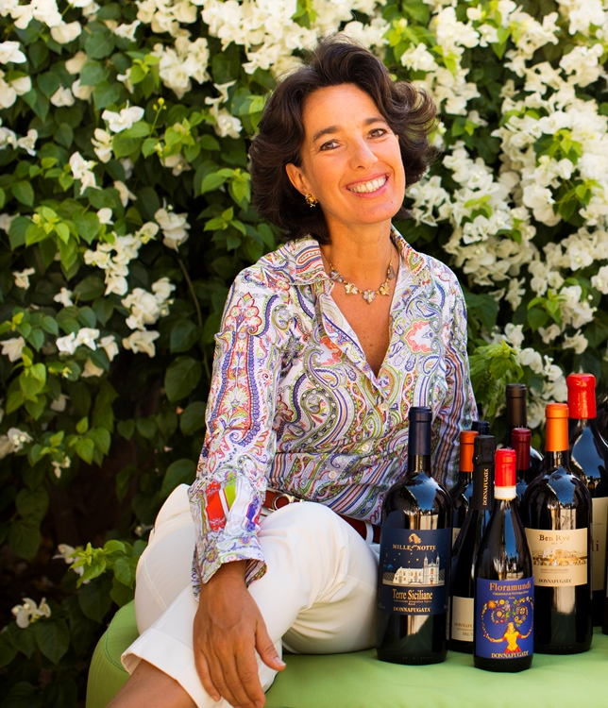
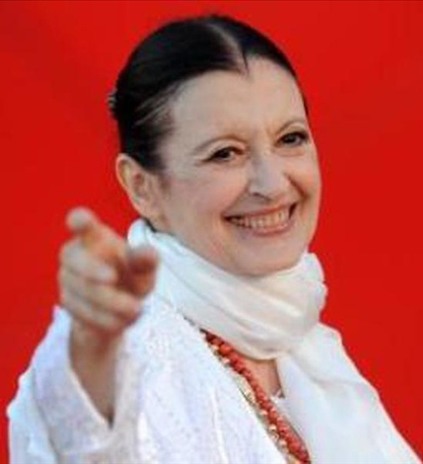
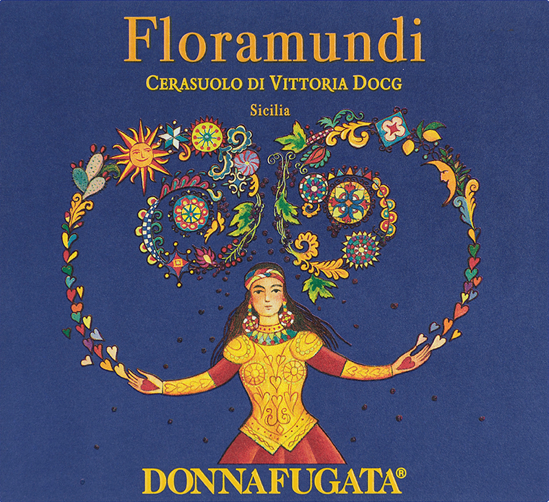

The theme of Art and Wine at Donnafugata embraces the entire production path of the Sicilian winery, and right from the start. The literary reference of its name, the originality of its labels and the fellowship with artist Stefano Vitale, and then, with José Rallo, owner of the winery, singer of Jazz paired with unmissable glasses of wine. An entrepreneurial story that has always sought the suggestions that art can generate around a label, a territory, a brand.
Now, with the emotion of the great encounters you will remember all your life, on the occasion of the launch of Floramundi, the latest wine born at Donnafugata, it is dance's turn to write a new page of the Art and Wine dialogue. Thus – at the invitation of Centro Danza Tersicore directed by Elisa Ilari who has been collaborating with Donnafugata for years – Carla Fracci in Marsala will be the patroness of Floramundi, the fruit of a project that proposes the excellence of Sicilian wine, from Contessa Entellina to Pantelleria, from Etna to Vittoria, all territories of extraordinary value.
On 2 December, in the company's historic cellars, in a press-only preview, Carla Fracci will be the star of Floramundi on stage, with which Donnafugata has wanted to pay homage to a universal legend of dance, linking it to the premiere presentation of its new wine. The great Italian dancer will recount the stages of her extraordinary career in the world's greatest theatres, interpreting roles that with her have become legend. Fracci recounts Carla, this is the most intimate dimension chosen to present the autobiography “Step by step” with which the prima ballerina of Teatro alla Scala, more famous than ever, wanted to tell us about herself.
Dancers of DJB Junior Ballet Company and Amilcar Moret Gonzalez will interpret the recount, with some of Fracci's most famous choreographies and others specially created for Floramundi, to celebrate the wine and flower theme.
“About Carla Fracci I admire the tenacious woman, the perfect artist and the elegance with which she has danced in the world – José Rallo of Donnafugata explains –; we are really grateful to her for having accepted the invitation to be the patroness of our Floramundi, a Cerasuolo di Vittoria with a flowery soul. Dance encounters wine evoking beauty and harmony.”
The label of Floramundi, born from the imagination of Stefano Vitale, with the interlacement of flowers and fruits with velvety tones, expresses the encounter between two souls, the sophisticated one of Floral Liberty and the suggestive one of the tradition of the Sicilian puppets. An artistic label that is an appropriate tribute to Carla Fracci, whose art and elegance evoke the beauty of all the flowers in the world.
In Marsala Carla Fracci will find the friendship and admiration of a whole city, thanks also to the work of Centro Danza Tersicore directed by Elisa Ilari who, with Donnafugata, has shared the organizational effort to bring her to the city of the Mille: the great Italian dancer will be on stage at Teatro Impero in Marsala, 3 December at 18.00.
Marsala, 23 November 2017
PRESS OFFICE Nando Calaciura calaciura@granviasc.it cell. 338 3229837
PUBLIC RELATIONS Baldo M. Palermo baldo.palermo@donnafugata.it tel. 0923 724226


Pre-sale online and at the following points of sale: "I Viaggi dello Stagnone" Agency, Via dei Mille 45, Marsala; Egatour Viaggi, Via Ammiraglio Staiti 13, Trapani; Cafè Argenteria, Via Argenteria 100, Casa Santa Erice.

Step by step, Fracci recounts Carla.
Giselle, Juliet, Cinderella, Medea, Swanilda, Francesca da Rimini... Carla Fracci has interpreted more than two hundred characters, more than two hundred roles, interpretations, stories portrayed on stage with extreme variety and exasperated sentiment, because "ballet has a language that is more penetrating than that of theatre, perhaps it is the absence of the spoken word to makes it so".
In an intimate autobiography, Carla Fracci recounts her childhood spent in the Lombardy countryside and when she was admitted to La Scala Theatre Ballet School, the graduating students' Passo d'Addio and the triumphs with American Ballet Theatre and on the world's most important stages: Los Angeles, Moscow, Havana, Tokyo, London.
Daughter of Luigi, tram driver, and Santina, worker, a distant relative of Giuseppe Verdi thanks to her grandfather's first wife, Carla confesses her love for family and honesty, for dance, that she wanted to take to the smaller centres, for music and harmony, "all that inspires me, even more than the environment".
Acclaimed by the most influential dance critics and warmly applauded by audiences of ever calibre, Carla Fracci has been the artistic partner of the most glorious dancers in the world: Erik Bruhn, Rudolf Nureyev, Michail Baryshnikov, Mario Pistoni and Paolo Bortoluzzi. And then Margot Fonteyn, Gelsey Kirkland, Alicia Markova. She has worked with choreographers such as John Cranko, Maurice Béjart and Antony Tudor, and her life has always been surrounded by poets, above all Eugenio Montale who dedicated to her the lyric poem: The tired dancer.
"It is thanks to these maestros that today, more than seventy years later, I don't feel at all tired" Carla says, and adds that she still has one big desire: "that in Italy a national ballet company is born, a company that can tour the world with our excellences without any fear of giving important opportunities to young dancers, above all, who should not feel forced to leave the country".

Centro Danza Tersicore
Centro Danza Tersicore in Marsala, directed by Elisa Ilari, is a classical and contemporary dance school that has been operating in the area of the province of Trapani for more than twenty years. A consolidated professional reality that has achieved remarkable results over the years: the admission of some students to La Scala Theatre Ballet School, Milan, the Accademia Internazionale Coreutica, Florence, participation in the masterclass of the Royal Ballet School, London Contemporary Dance School, the admission of some students to the Rotterdam Dance School, and Teatro dell’Opera, Rome. Over these years Centro Danza Tersicore has been awarded in several national and international dance competitions: such as the Spoleto festival and the Rieti International Competition. The school has collaborated with the most important institutions in the area, such as the Diocese of Trapani, the Italian Red Cross and the Superintendence for Cultural Heritage, several service clubs and the Trapani Police Headquarters. The students of Centro Danza Tersicore have danced in several performances including Octavia by Seneca on stage at Teatro Antico, Segesta, directed by E. Siravo with choreography by Elisa Ilari, artistic director; in the performance “Un castello di cento stanze” by Claudio Forti directed by G. Zanetti, and “Empedocle il carceriere del vento” directed by Mario Mattia Giorgetti and with the participation of actor Pino Caruso, in the international festival “Circuit of Myth, Sicily 2010”. In addition, they have collaborated with Teatro Nuovo, Turin, in several performances for the Asti Teatro festival.

