PRESS RELEASE
From Etna and Pantelleria, the new Donnafugata olive oils.
Two monocultivar extra virgin olive oils made from Nocellara Etnea and Biancolilla; in addition to the wine, the challenge to thrill quality oil lovers.
Donnafugata enriches its range with two new olive oils that express the quality of their territories of origin. A challenge that runs parallel to the wine production that has made the Sicilian winery well known, and that testifies to the desire to also thrill quality oil lovers.
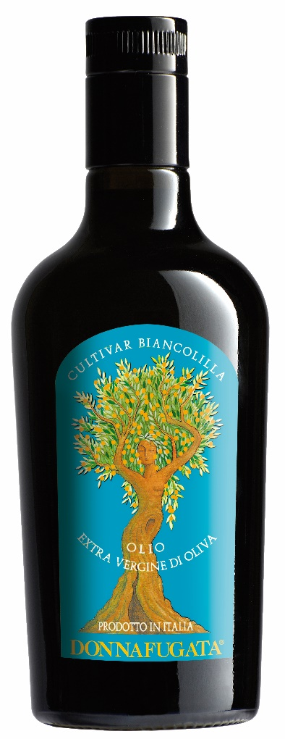
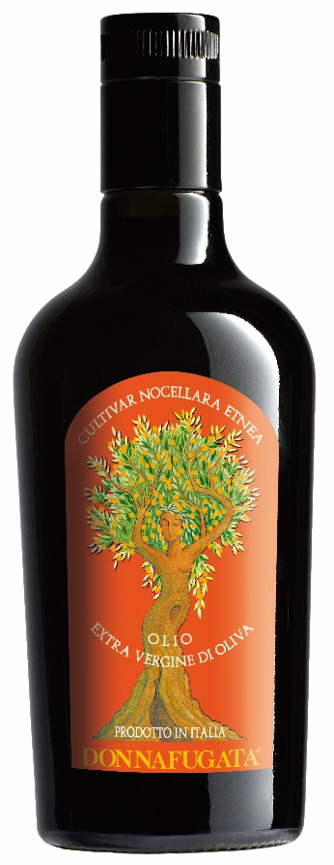
The extra virgin made from the Nocellara Etnea cultivar was produced from the winery's olive groves located on the north side of Etna, where Donnafugata has been committed since 2016.
The Nocellara Etnea olives were harvested by hand in the second half of November, and they have created an oil characterized by medium intensity fruitiness, with enveloping scents of cut grass and artichoke. The harmonious balance between bitter and spicy makes this oil particularly pleasant on the palate, enhancing the notes of walnut and chestnut.
The monocultivar oil made from Nocellara Etnea is a versatile oil that excels drizzled over mushroom-based soups, roasted meats and grilled vegetables.
On Pantelleria, where the olive trees are cultivated on terraces and pruned low to protect them from the wind, the cultivar is Biancolilla.
Harvested during the second ten days of October, the Biancolilla olives have created a light, delicate oil of extraordinary elegance; the bouquet is characterized by light intensity fruitiness, with scents of ribbed tomato, aromatic herbs, rosemary and thyme. An extra virgin that excels as a condiment for fish, salads and in delicate preparations such as a gourmet mayonnaise.
Nocellara Etnea and Biancolilla – like Milleanni, the oil produced by Donnafugata from the olive groves at the Contessa Entellina estate – are obtained by cold milling the olives, with malaxation in a controlled atmosphere: a procedure that allows you to protect the oil from oxidative processes and best enhance its quality and aromatic fragrance.
The two new olive oils will be proposed to restaurants and wine shops, in the elegant bottle (500 ml format) on which one of the many female figures that are the protagonists of Donnafugata labels stands out, a woman - olive tree, symbol of serenity and well-being.

Marsala, 29 January 2018

PUBLIC RELATIONS Baldo M. Palermo baldo.palermo@donnafugata.it ph. +0923 724226
Laura Ellwanger pr.international@donnafugata.it ph. +39 0923 724258
PRESS OFFICE Nando Calaciura calaciura@granviasc.it mob. +39 338 3229837
PUBLIC RELATIONS Baldo M. Palermo baldo.palermo@donnafugata.it tel. 0923 724226

