PRESS RELEASE
Gabriella Anca Rallo awarded by Terre Sicane
The “Donne & Vino 2018” Award has been given to her by the Terre Sicane Wine Route. The ceremony Saturday 10 March in Sambuca di Sicilia.
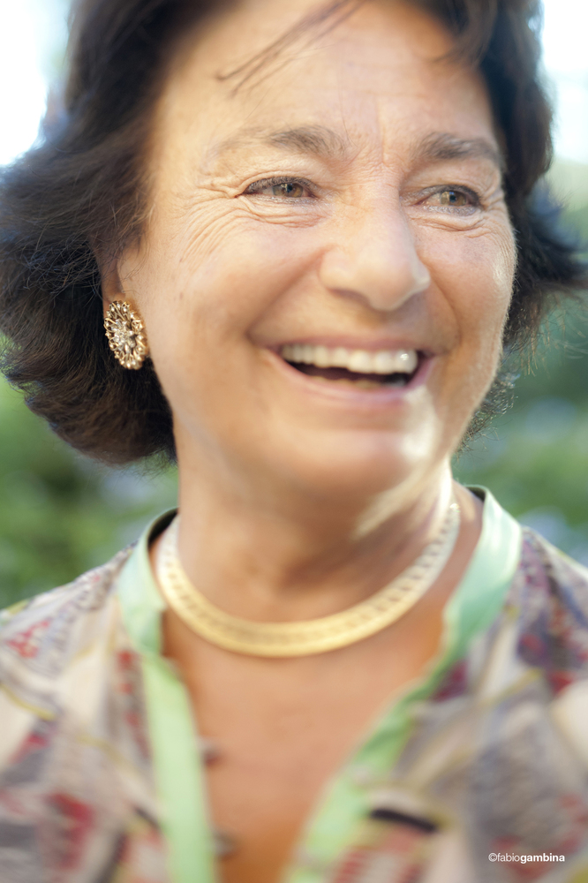
The culture of wine and the land owes a great deal to her, and not only in Sicily. An authentically female production story, the one recited by Gabriella Anca, founder with Giacomo Rallo of the Donnafugata winery.
Pioneer of the new direction of Sicilian wine, today Gabriella is its authoritative and beloved ambassador, having embodied, for a lifetime, the values of a hard-working and innovative Sicily.
An enterprise that embraces forty years of professional history, from viticulture to communication where she gave life to Donnafugata's artistic labels. Terre Sicane will pay tribute to her by giving her the award "Donne & Vino 2018": the ceremony will take place March 10, in the eighteenth century Palazzo Panitteri in Sambuca di Sicilia, one of “Italy's most beautiful villages”.
"The wine award Donne&Vino - says Gunther Di Giovanna, president of the Terre Sicane Wine Route Association - intends to enhance the value of those women who have chosen to dedicate themselves to the world of quality wine. It is a recognition that aims to strengthen the link between wine and culture through the female experience of wine."
With her husband Giacomo, Gabriella Anca created Donnafugata in 1983 after taking, a few years earlier, ownership and leadership of the family estate in Contessa Entellina, in the heart of western Sicily. Since then, her great contribution to Donnafugata's ascent to the top of the Italian and international winemaking scene has contributed decisively to the achievement of the quality and image of the island's viticulture.
"It is a recognition that makes me happy - Gabriella herself explains - I'm very attached to Terre Sicane and therefore to Contessa Entellina, Sambuca di Sicilia and Santa Margherita Belice where today we have 270 hectares of vineyards in production. This is the land of my life, its colors are the protagonists of our artistic labels. Here, together with my husband and children, we grew our company. With sacrifice and dedication we have always favored quality, an added value that has allowed us to reveal the uniqueness of our viticulture to the world."
An enterprise, that of Donnafugata, that with Gabriella Anca and Giacomo Rallo first, and today with their children José and Antonio, has made an important contribution to the growth of the Terre Sicane villages, that this prize intends to recognize.
Marsala, 7 March 2018

PRESS OFFICE Nando Calaciura calaciura@granviasc.it cell. 338 3229837
PUBLIC RELATIONS Baldo M. Palermo baldo.palermo@donnafugata.it Tel. +39 0923 724226

PUBLIC RELATIONS Baldo M. Palermo baldo.palermo@donnafugata.it tel. 0923 724226

