PRESS RELEASE
SUL VULCANO, Etna according to Donnafugata
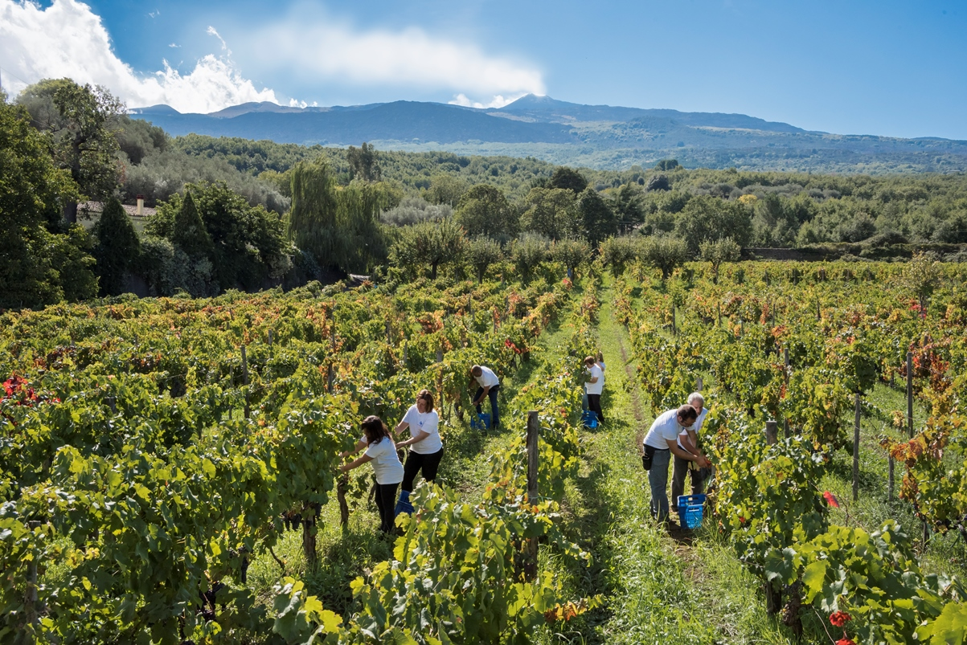
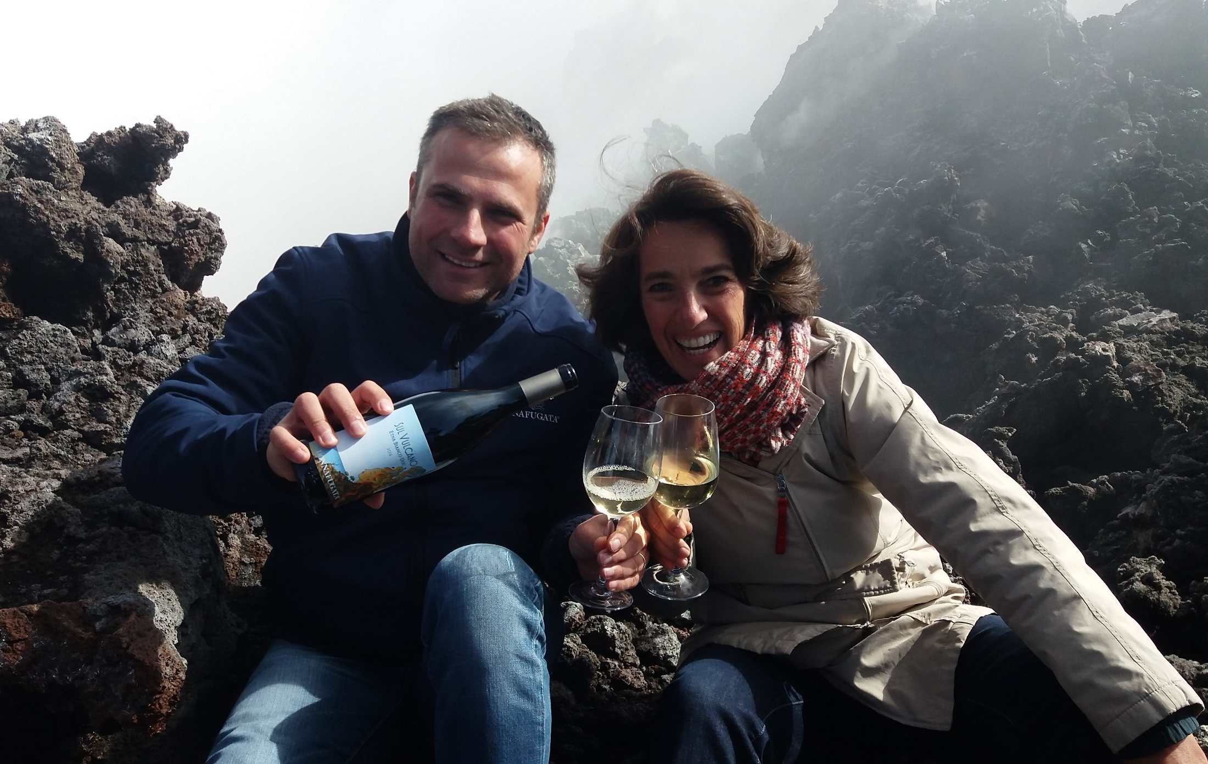
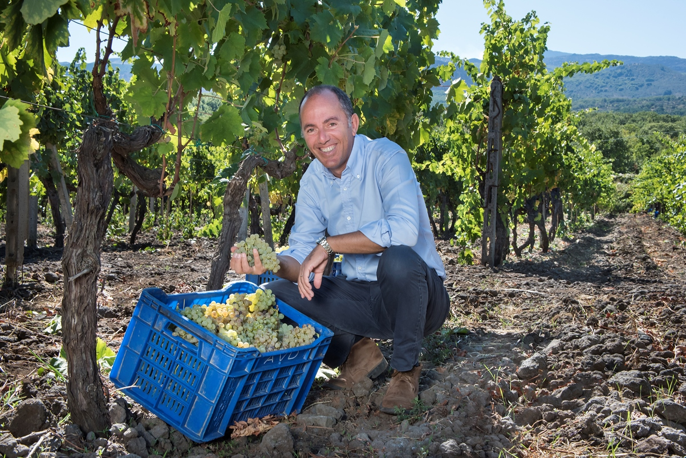
Vinitaly 2018: the Sicilian winery presents its latest born SUL VULCANO Etna DOC white, the fruit of the winery's commitment in eastern Sicily that, after the release of the wines of Vittoria, completes the enological project inspired by Giacomo Rallo and carried on by his family: pursue the excellence of Sicilian wine in different territories, all with extraordinary potential.
After the wines of Vittoria proposed last year, Donnafugata presents its latest prestigious novelty produced on Etna where the winery counts on 15 hectares (37 acres), spread over 5 different districts on the north slope of the great mountain, between Randazzo and Passopisciaro, over 700 meters above sea level.
Donnafugata is thus preparing to live one of its most important Vinitaly fairs due to the release of the first wine produced under the Etna denomination: it is called SUL VULCANO and it represents a small, prestigious production of only 7,000 bottles, the fruit of the 2016 harvest vinified in the company's winery in Randazzo.
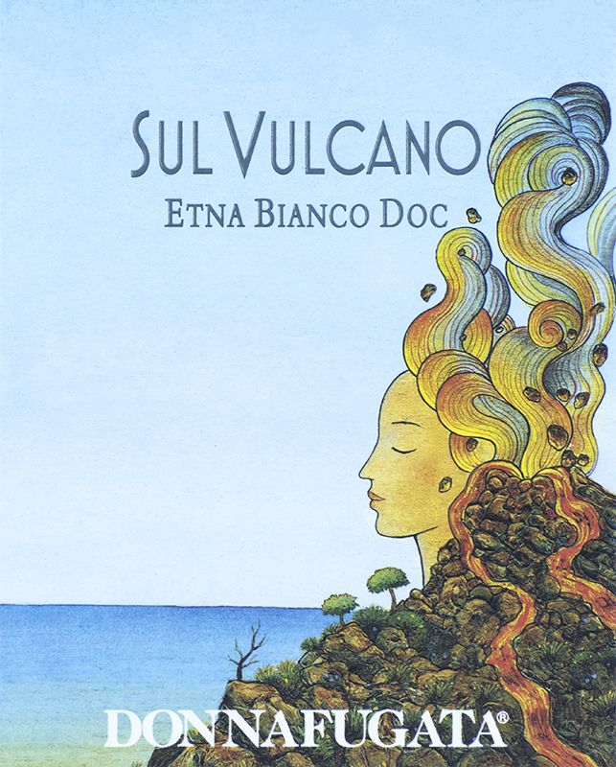
Produced from Carricante grapes, the ancient white grape variety cultivated on the slopes of Etna, SUL VULCANO is an enveloping wine, of great persistence, elegance and complexity, that reflects the style of Donnafugata marked by the pursuit of the excellence of Sicilian wine from different territories, all with extraordinary potential.
“With the 2016 harvest - recounts Antonio Rallo of Donnafugata - our commitment on Etna began. Two years later, with great emotion, we are presenting our first wine, the fruit of a project over which we had long meditated with my sister José and our parents Giacomo and Gabriella. I am convinced that SUL VULCANO deeply expresses this unique terroir and the varietal identity of Carricante; I feel that this great mountain is a lucky star for those who commit themselves to producing the highest quality.”
“For the label - José Rallo says - we have chosen a new, extraordinary illustration by Stefano Vitale, the artist who has been collaborating with us for over 20 years, giving life to an identity communication; it is a goddess-volcano with intense colors: red, yellows, iridescent blacks, those of the highest active volcano in Europe. An ancient deity, powerful and feminine, <the Mountain> as Etna is called by the locals. SUL VULCANO - José Rallo concludes - is our declaration of love for this territory: it is a pure wine, with marked minerality, that lets you breathe the energy of this special place, at the center of the Mediterranean, and for this, in the Donnafugata Collections, it has been placed among the Surprising Wines, to drink when you desire originality”.
Marsala: April 13th, 2018

PUBLIC RELATIONS Baldo M. Palermo baldo.palermo@donnafugata.it ph. +0923 724226
Laura Ellwanger pr.international@donnafugata.it ph. +39 0923 724258
PRESS OFFICE Nando Calaciura calaciura@granviasc.it mob. +39 338 3229837 baldo.palermo@donnafugata.it tel. 0923 724226

