PRESS RELEASE
At Donnafugata the Invisible Orchestras of the Night Harvest
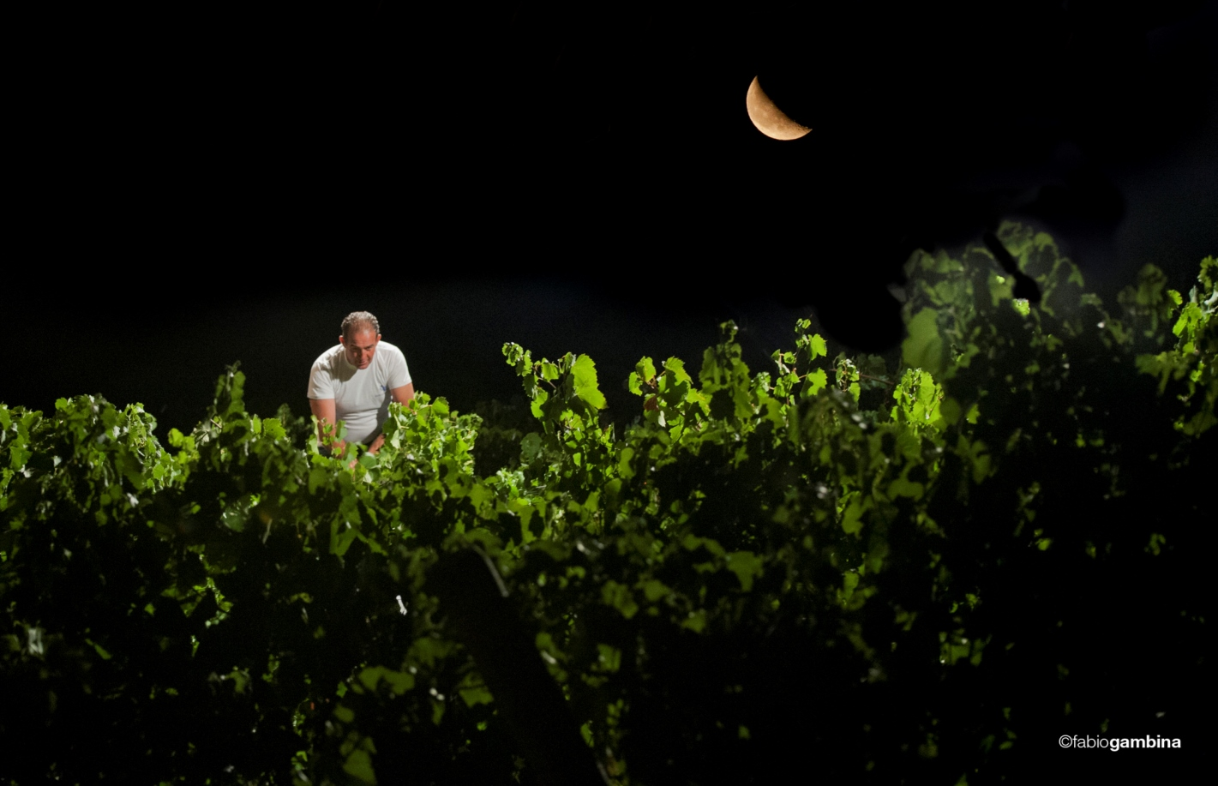
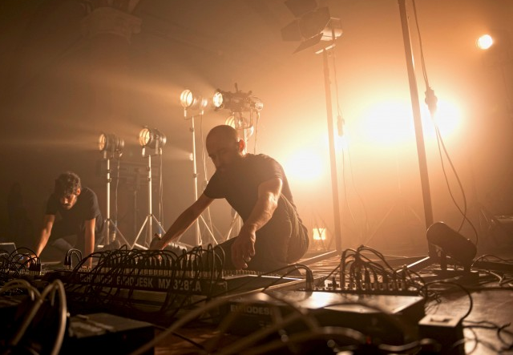
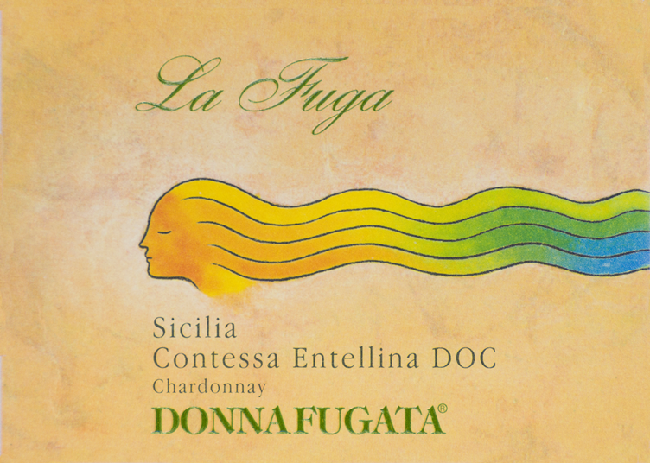
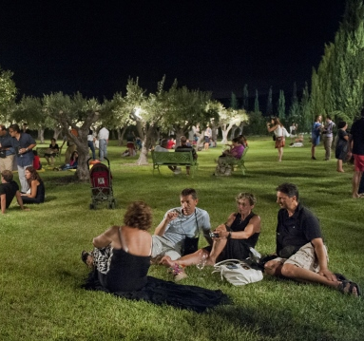
Calici di Stelle is back with the binomial art and wine: at Donnafugata's big festival, the multimedia artists Quiet Ensemble will be playing, with their live performance dedicated to the night harvest.

The most awaited Donnafugata event, now in its twenty-first edition, proposes a fresh new interpretation of the night harvest, where Art and Wine become one, to excite and entertain those who accept Donnafugata's invitation. The seemingly quiet countryside hides an invisible orchestra that on August 10, on the occasion of Calici di Stelle (Goblets of Stars), will come to life through an unprecedented performance.
On the night of San Lorenzo and the shooting stars organized by the Wine Tourism Movement, at Donnafugata winelovers will live a memorable festival characterized by multimedia art and quality wine.
The guests of Calici di Stelle will make a first stop at the La Fuga vineyard - the Chardonnay from the harvest by moonlight - that for the occasion will become an extraordinary theater of sounds and lights curated by Quiet Ensemble that will stage Invisible Orchestras of the night harvest.
The wind that blows on the vine leaves, the chorus of cicadas and the noises of the work of men will be the elements of a musical and visual score of rare expressive effectiveness; an unexpected symphony that reveals to the public the microscopic wonders of the night harvest.
The performers, Bernardo Vercelli and Fabio Di Salvo, are artists known internationally for their ability to unveil the most hidden face of nature and the work of men, through the use of multimedia technologies. In the heart of the Donnafugata vineyard, under the artistic direction of Gaetano La Rosa, the Quiet Ensemble will orchestrate sounds and images, amplified and projected among the rows, in a lighting setup that creates a surprising effect.
After the tour of the vineyard, the winery tour will follow, and the grand tasting of all the company's wines with over 20 labels to be tasted in the striking garden of the family estate in Contessa Entellina (at km 60 of the S.S. 624).
In the new collection of Surprising Wines, Sul Vulcano Etna Rosso DOC 2016, the new prestigious Nerello Mascalese, the fruit of Donnafugata's commitment in this territory of extraordinary charm and high-quality wine, debuts.
From the winery's historic reserve, some rare and precious vintages of wines such as Vigna di Gabri, the cru dedicated to Gabriella Rallo, founder of Donnafugata together with her husband Giacomo, and Chiarandà, flagship white wine produced at Contessa Entellina, will also be tasted. And for the lovers of long-lived wines, there will also be some unobtainable vintages of the Donnafugata icon wines, the red Mille e una Notte and the Passito di Pantelleria Ben Ryé.
Marsala, 13 July 2018
PUBLIC RELATIONS Baldo M. Palermo baldo.palermo@donnafugata.it ph. +0923 724226
Laura Ellwanger pr.international@donnafugata.it ph. +39 0923 724258
PRESS OFFICE Nando Calaciura calaciura@granviasc.it mob. +39 338 3229837

Calici di Stelle: 10 August 2018, from 21.00 to 01.00; Donnafugata estate, km 60 S.S. 624 Palermo-Sciacca highway.
INFO: online presale, places are subject to availability http://visit.donnafugata.it/it-it/eventi/calici_di_stelle; 25 euros plus 5 euros glass deposit; admission is free for under 16s. Lastly, a fundamental logistics note: the Donnafugata estate is located at precisely km 60 of the S.S. 624, along the Palermo-Sciacca highway.

