PRESS RELEASE
2018 Harvest at Donnafugata
The trend of the vintage in Contessa Entellina, Pantelleria, Vittoria and on Etna.

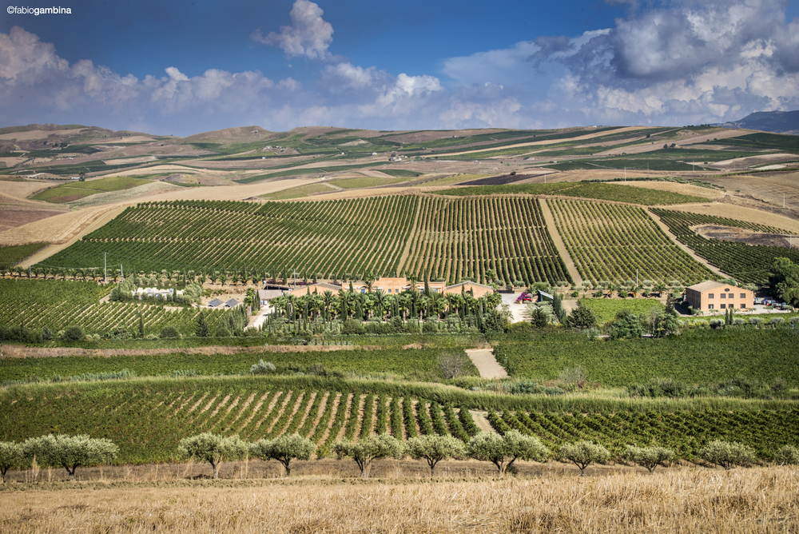
In Contessa Entellina in the heart of western Sicily, after two rather dry vintages, 2018 was a vintage with more rainfall, with 743 mm of rainfall compared to the average of 667 mm*. Most of the rainfall occurred in spring, while in summer there was intense rainfall in some areas of the estate. Careful management of the agronomic practices, from pruning to cluster thinning and the choice of different harvesting times, allowed us to have healthy and well-ripened grapes. The harvest was therefore in line with the qualitative objectives of the winery oriented towards precious small productions.
*The rainfall data are calculated from 1 October to 30 September of the following year; the rainfall average is calculated starting from the 2003 harvest and obtained from SIAS, Sicilian Agrometeorological Service.

The harvest started on 6/8 with the harvesting of the Pinot Nero and Chardonnay for the production of the metodo classico sparkling wines, Brut and Brut Rosé. The nighttime harvest of the Chardonnay La Fuga concluded in the first ten days of August, and was followed by the harvesting of Sauvignon Blanc and Viognier. The autochthonous whites, Grillo, Ansonica, Grecanico and Lucido (Catarratto), were harvested between the first and second ten days of September.
Among the red grapes, Merlot was the first variety to reach ripeness during the last ten days of August, followed by the harvesting of Alicante Bouchet and some plots of Nero d’Avola and Syrah. Tannat, Petit Verdot and Cabernet Sauvignon were harvested between the first and second ten days of September. The harvest concluded on 26/9 with harvesting in the last Nero d’Avola vineyards.
Also on Pantelleria where Donnafugata cultivates 68 hectares of vineyards located in 14 different districts, after two rather dry vintages, 2018 was a vintage with more rainfall, recording 591 mm of rainfall compared to the average of 460 mm*. The quantity of Zibibbo produced was slightly higher than the last two vintages, therefore, in some vineyards, cluster thinning was performed in order to reduce the crop load and bring into the winery grapes that were perfectly ripe and rich in aromas. The harvest began on 17 August and concluded on 6 September.
* The rainfall data are calculated from 1 October to 30 September of the following year; the average is calculated starting from the 2013 harvest.

In south-eastern Sicily, in Acate, Donnafugata cultivates 36 hectares of vineyards and produces Frappato and Cerasuolo di Vittoria. In this territory, the climatic trend of the vintage was fairly normal with slightly above average rainfall, mainly concentrated in spring and in some days of summer. Accurate agronomic management favored a harmonious vegetation-production cycle, giving rise to grapes that achieved the right sugar, aromatic and phenolic ripeness. Unlike the previous vintage, there was no premature ripening; harvest time was chosen with extreme care, thus some Frappato vineyards were harvested between 10/9 and 12/9 and others between 17/9 and 23/9; instead, the Nero D’Avola harvest took place from 17/9 to 24/9.
On Etna, where Donnafugata cultivates 18 hectares of vineyards in five different districts between Randazzo and Passopisciaro, 2018 was a cooler and rainier vintage than the last two vintages; a typical Etna vintage with rainfall recorded in spring and summer, quite usual for vineyards located higher than 700 m. above sea level; in particular, rainfall between mid-August and early September exalted freshness and aromas. On this side of the volcano the following weeks were dry; this climatic factor together with the choice of performing some cluster thinning favored the desired ripening and regular harvesting.
The Carricante harvest began on 26/9 and concluded in a few days. The Nerello Mascalese harvest took place with several passes through the vineyards: from 28/9 with the selection of the clusters for the production of the new rosé; while for the reds the harvest continued from 5/10 to 8/10 in the Montelaguardia district, on 9/10 and 11/10 in the Marchesa district, and then concluded on 12/10 in the other districts.
The 2018 white and rosé wines are particularly fragrant with excellent acid structure; the reds are very elegant with extremely fine and well-integrated tannins.
Marsala, 20 October 2018

PUBLIC RELATIONS Baldo M. Palermo baldo.palermo@donnafugata.it Tel. +39 0923 724226
Laura Ellwanger pr.international@donnafugata.it Tel. +39 0923 724226

PRESS OFFICE Nando Calaciura calaciura@granviasc.it cell. +39 338 3229837
PUBLIC RELATIONS Baldo M. Palermo baldo.palermo@donnafugata.it tel. 0923 724226

